# VOYAGE VISTA: ILLUMINATING INSIGHTS FROM UBER EXPENDITIONARY ANALYSIS

# 1. Introduction

1.1. Overview

Analyzing Uber’s journey from a vista perspective can provide illuminating insights. Uber, founded in 2009, disrupted the traditional taxi industry by introducing a user-friendly app for on demand-rides.

1.2. Purpose

The expenditionary analysis of Uber offers valuable insights into business strategy, entrepreneurship, industry dynamics, and societal impact, making it a rich source of information and lessons for a wide range of stakeholders.

# 2. Problem statement and Design thinking

This presents a problem for those seeking comprehensive insights into the company’s evolution and its impact on the transportation and food delivery industries.

By employing design thinking, you can create an engaging and informative resource that addresses the problem of scattered information and empowers stakeholders with illuminating insights from Uber’s expenditionary analysis.

2.1 Empathy Map:

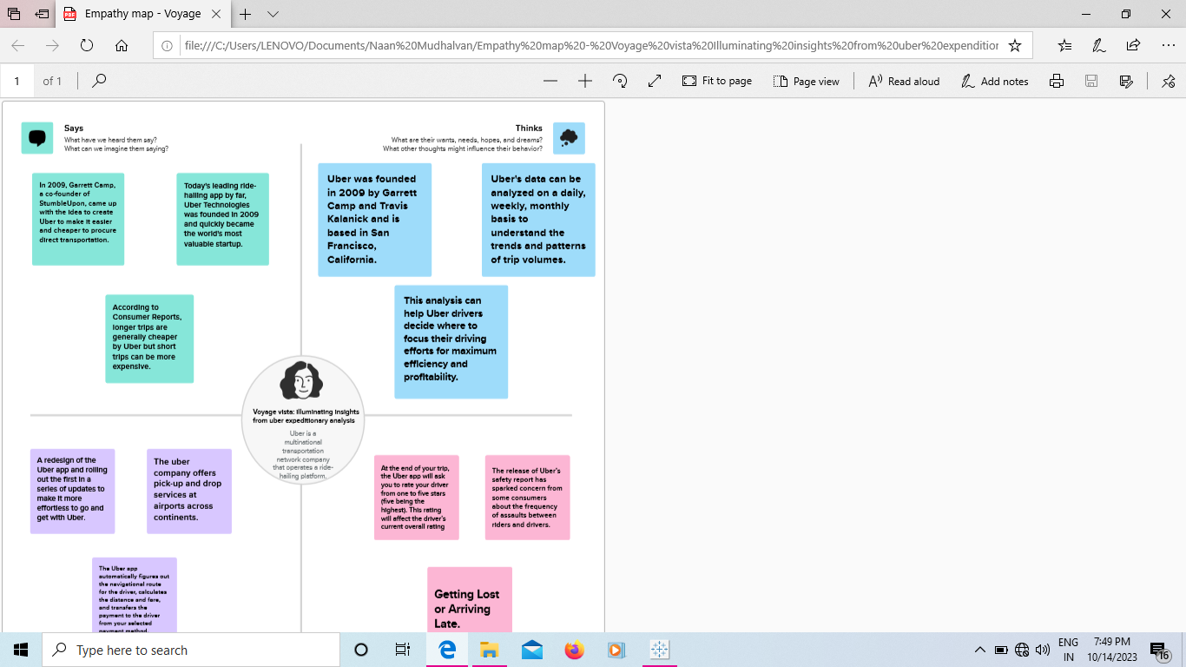

2.2 Ideation and Brainstorming Map:

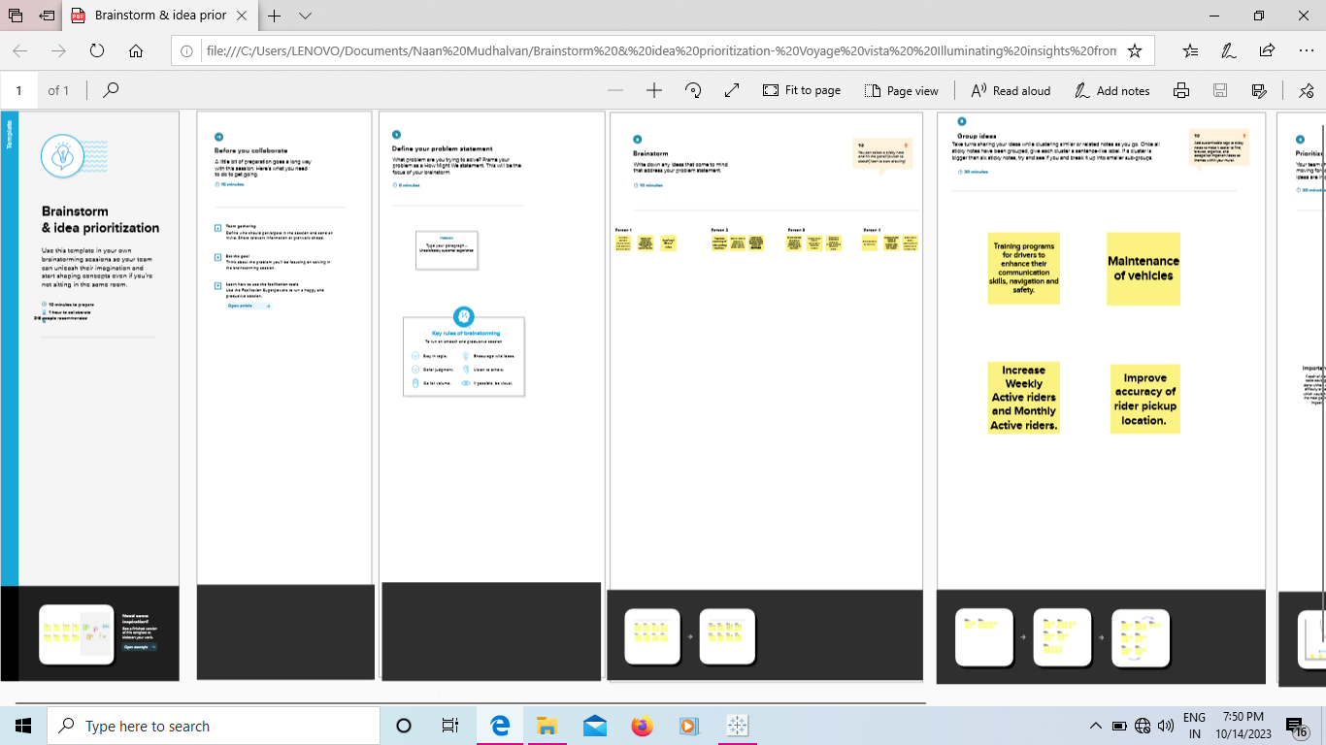

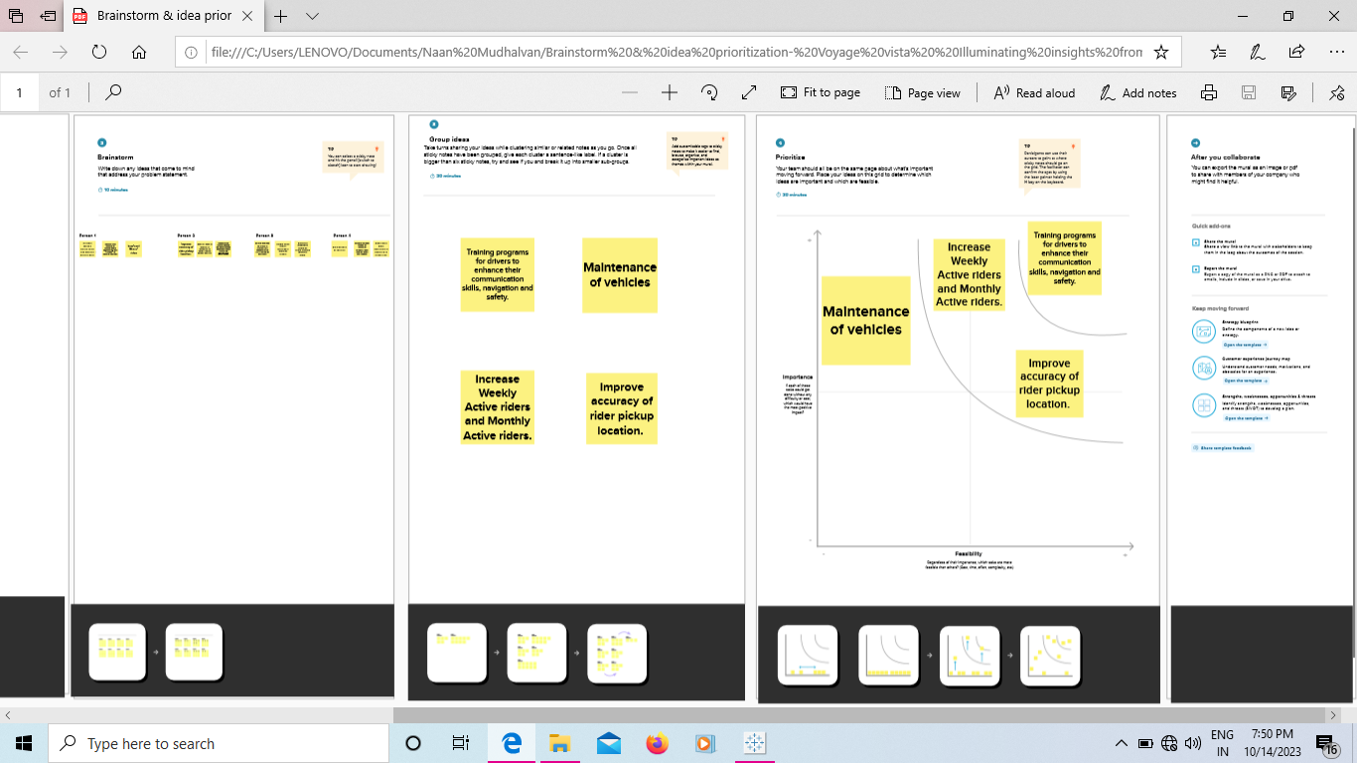

# 3. Result

Sheet 1: Miles Covered per category and purpose Analysis

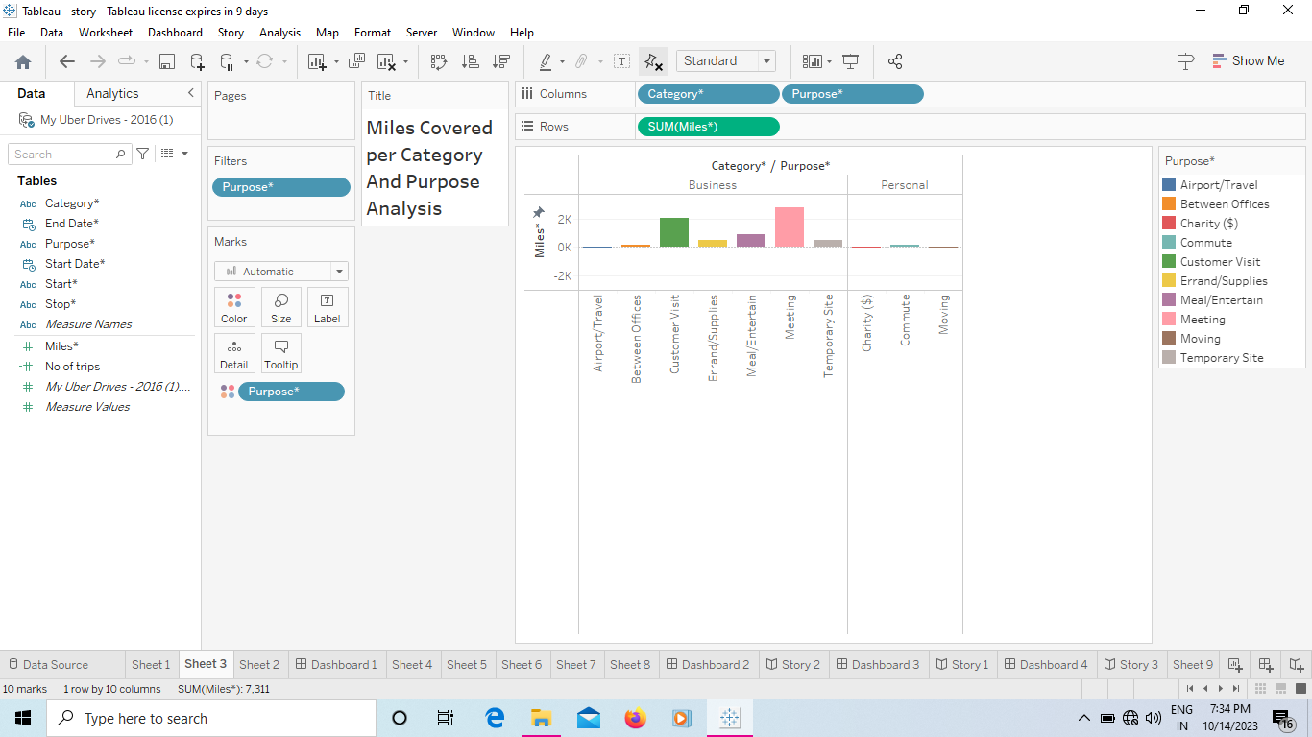

Sheet 2: Miles covered in category Analysis

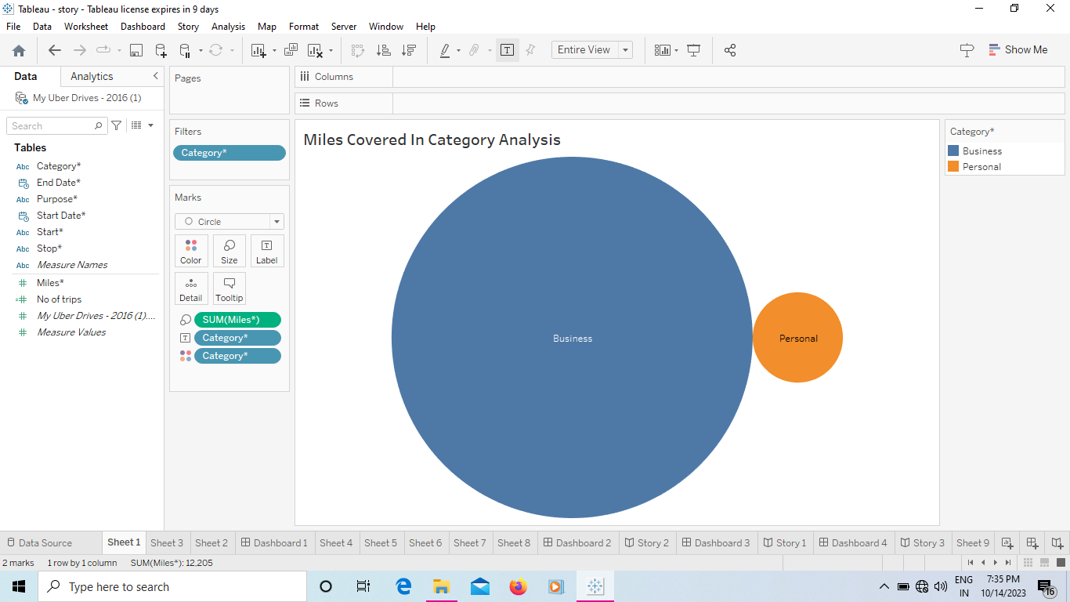

Sheet 3: Month wise Uber Miles Analysis

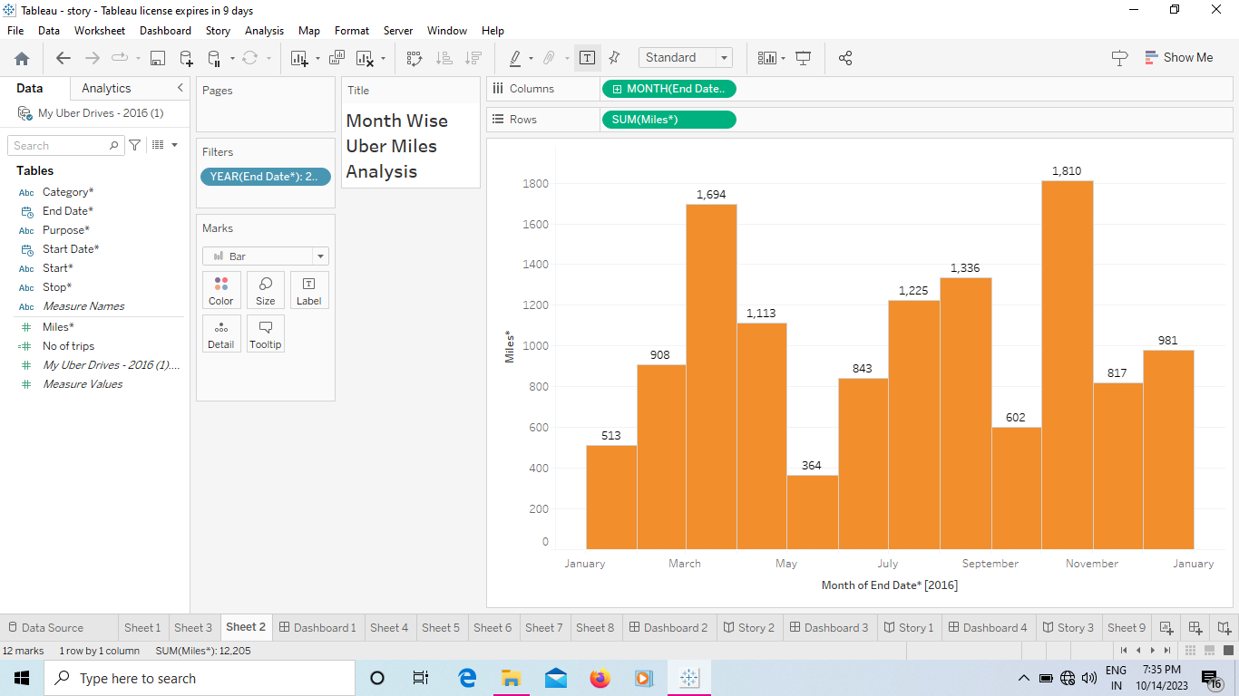

Sheet 4: Weak wise Miles covered Analysis

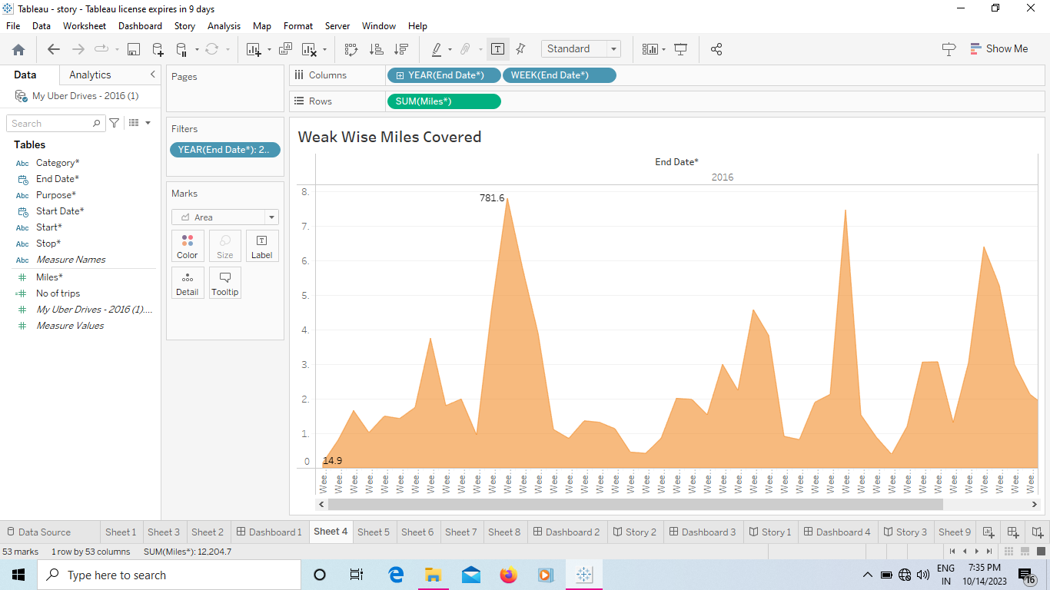

Sheet 5: Quarter Wise Miles covered Analysis

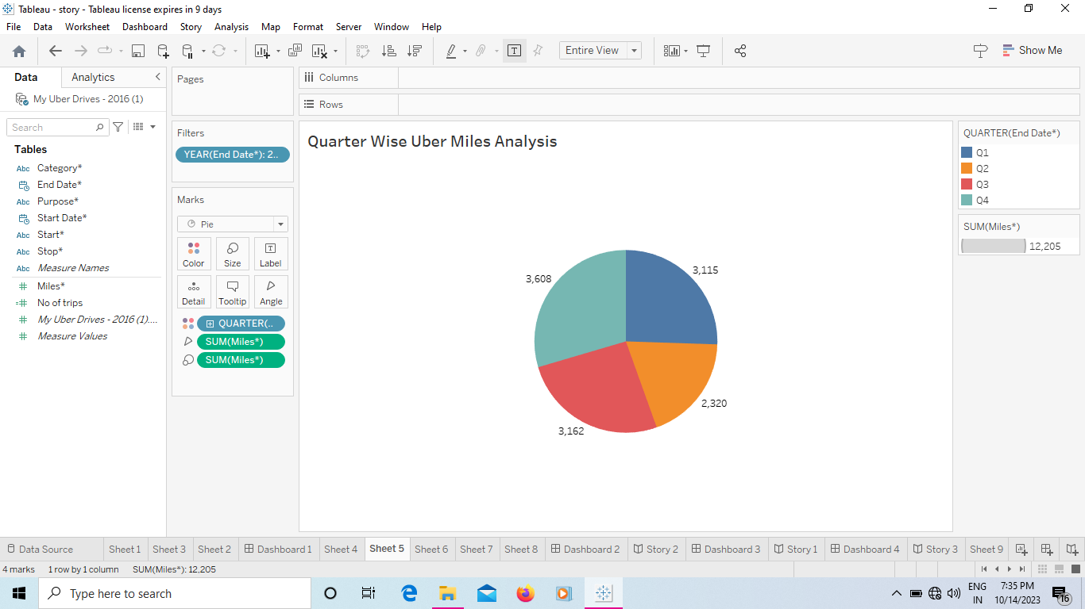

Sheet 6: Month Wise Uber Trips Analysis

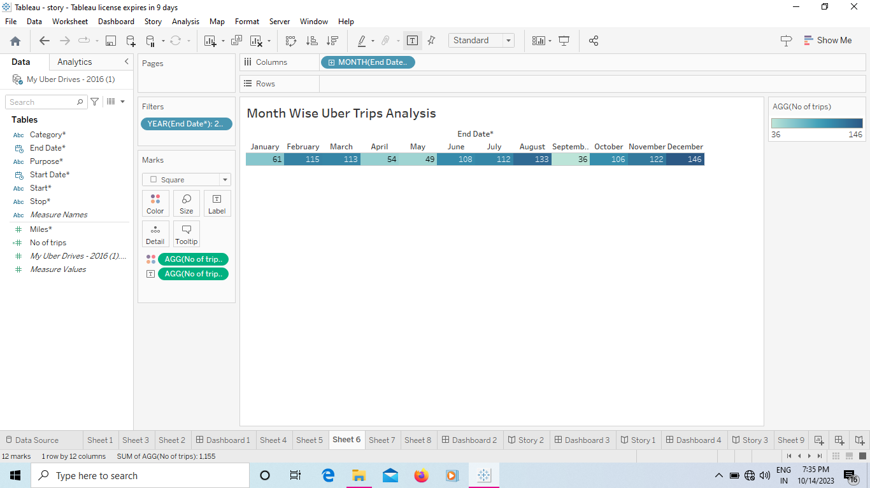

Sheet 7: Quarter Wise Uber Trips

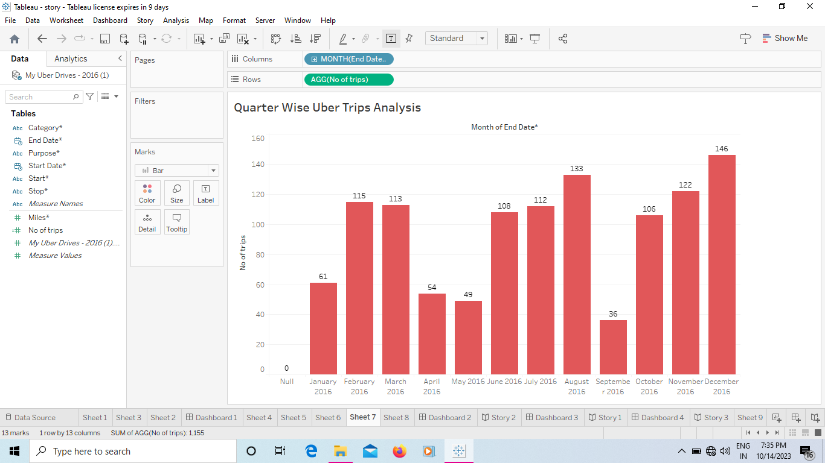

Sheet 8: Hour wise Uber Trips

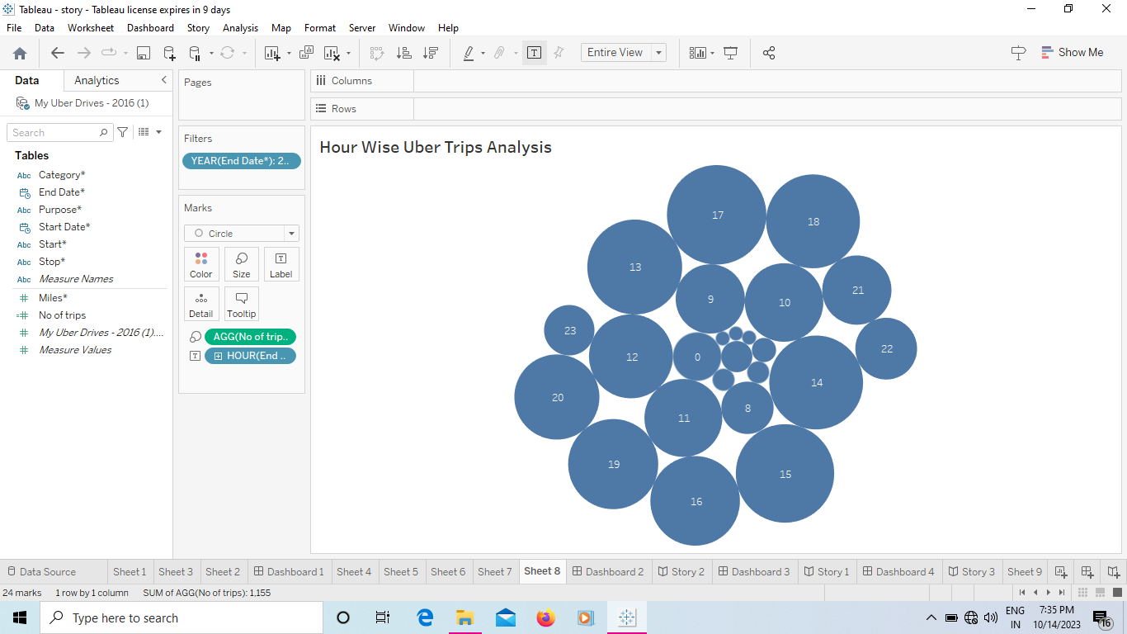

Dashboard 1

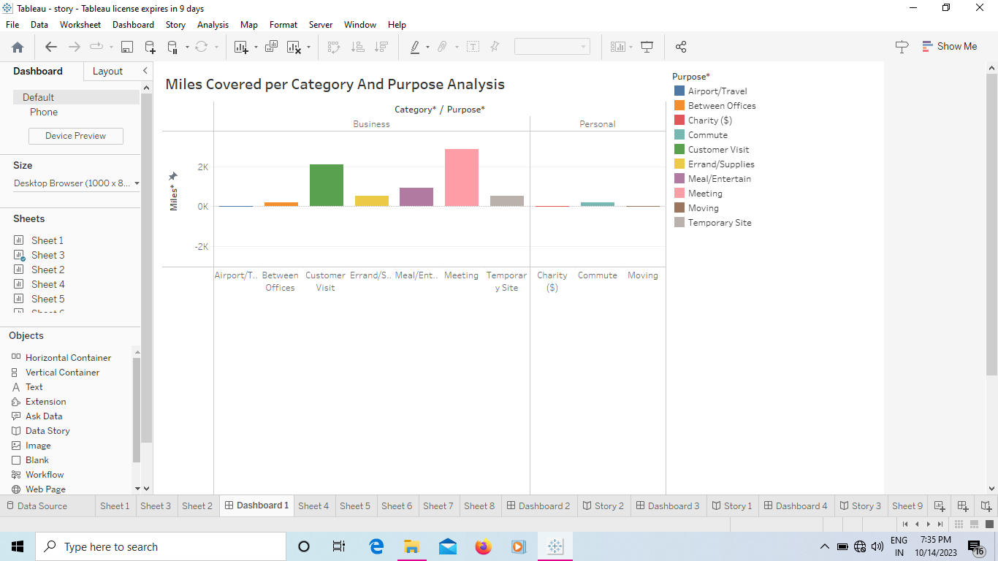

Dashboard 2

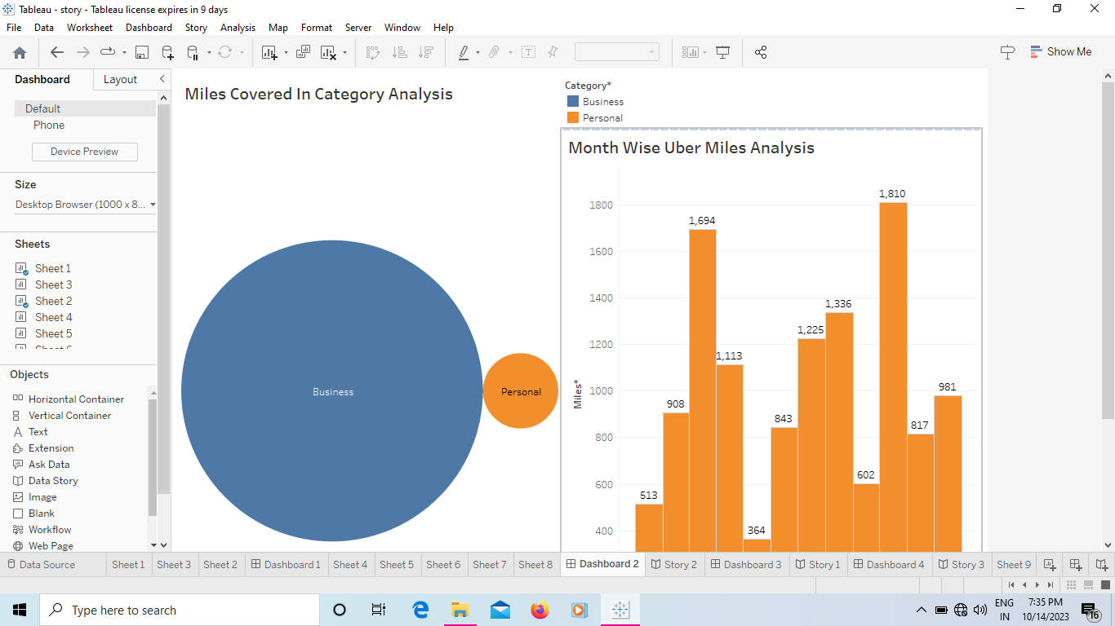

Dashboard 3

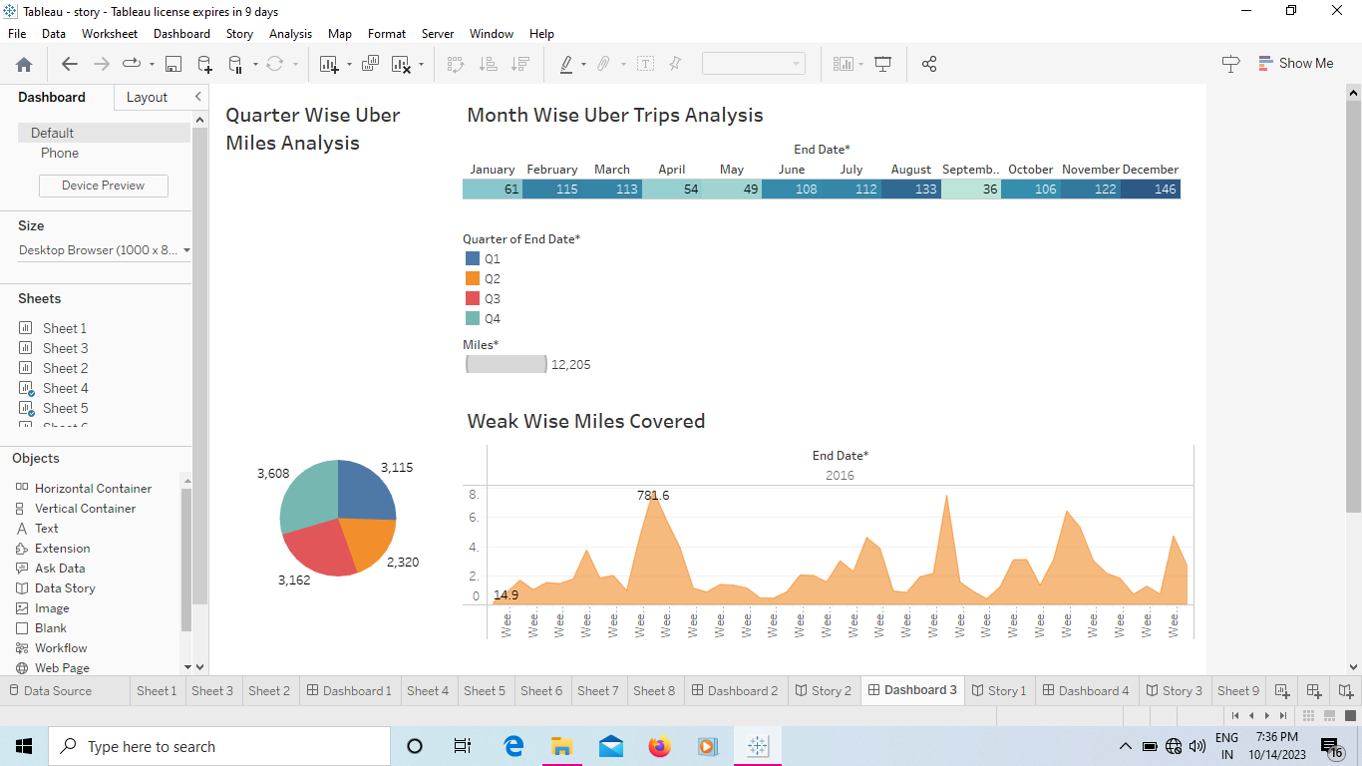

Dashboard 4

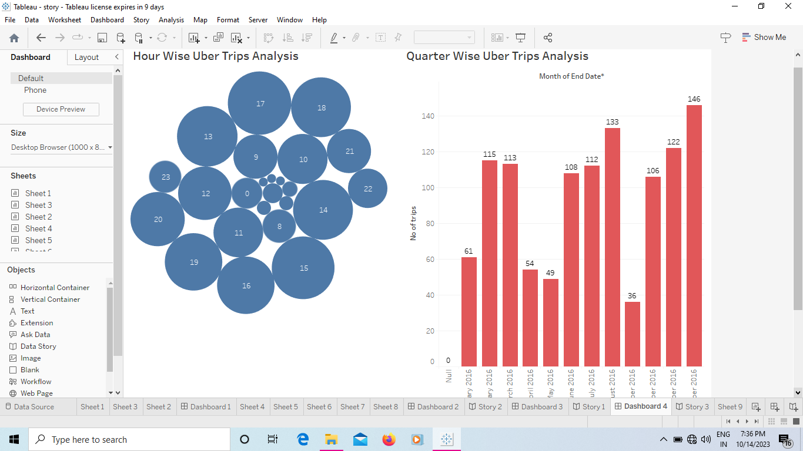

Story

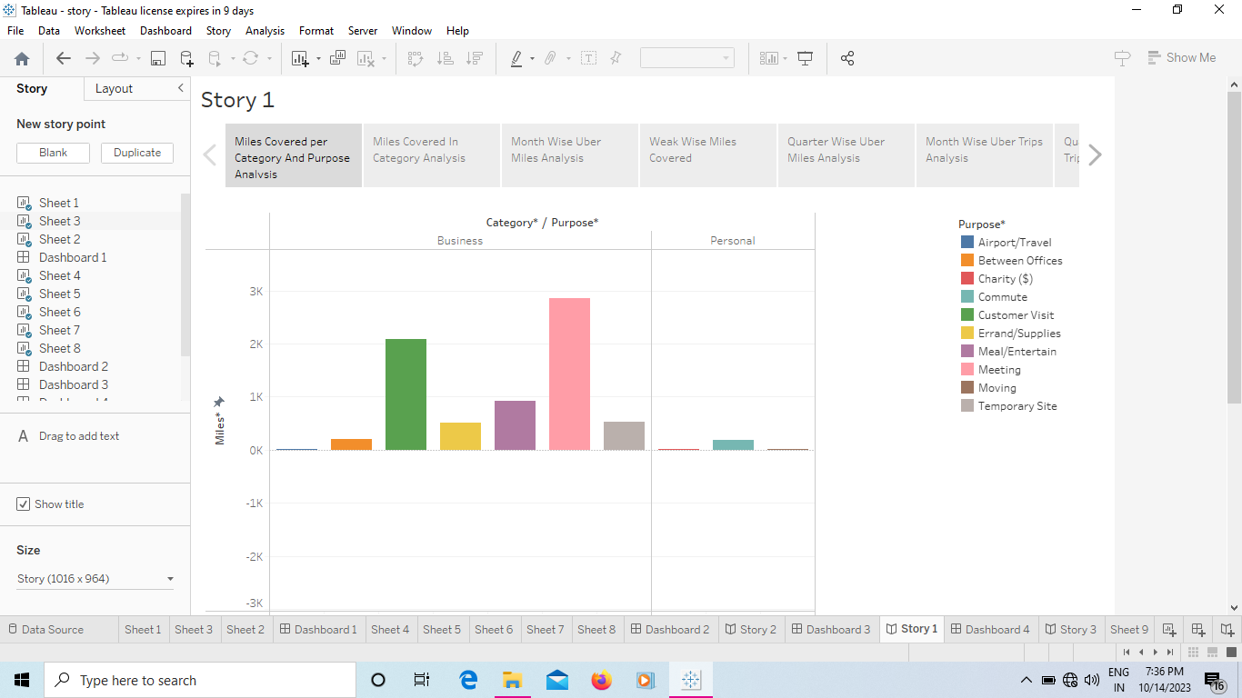

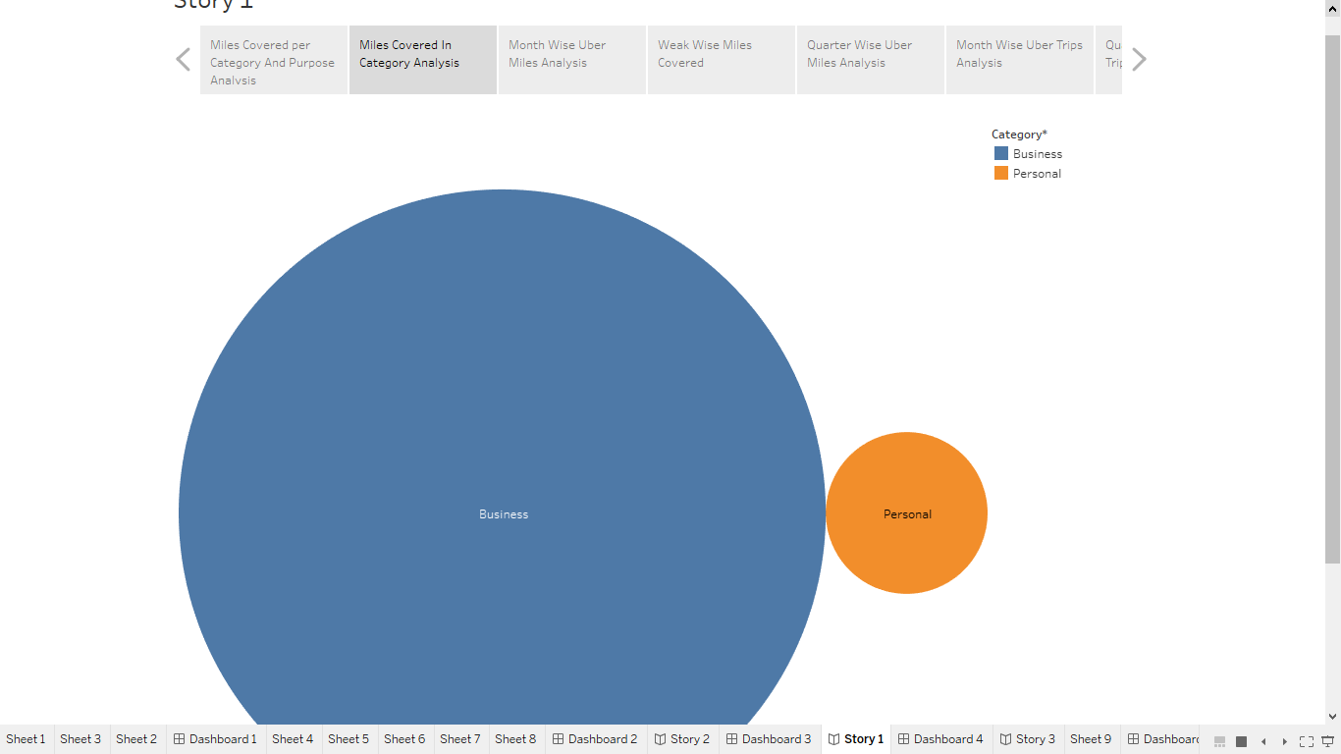

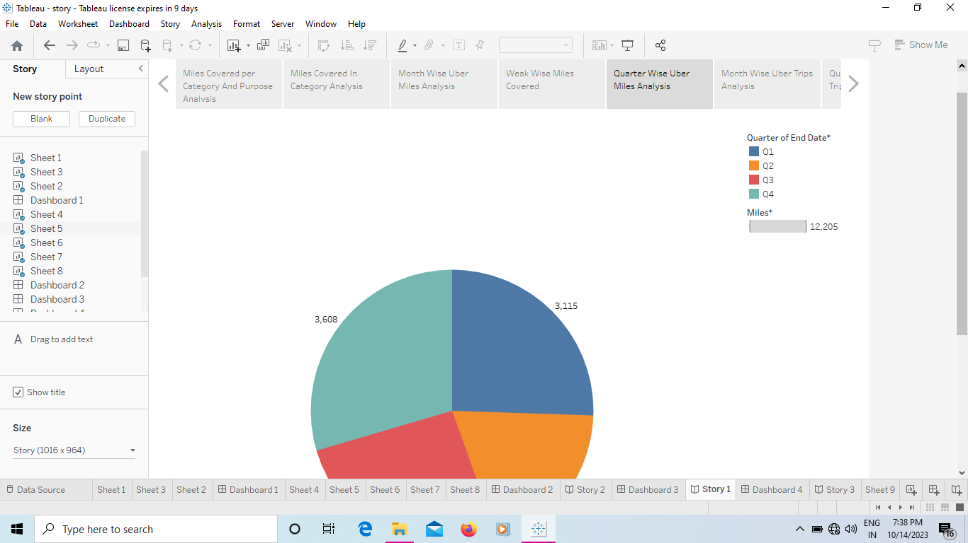

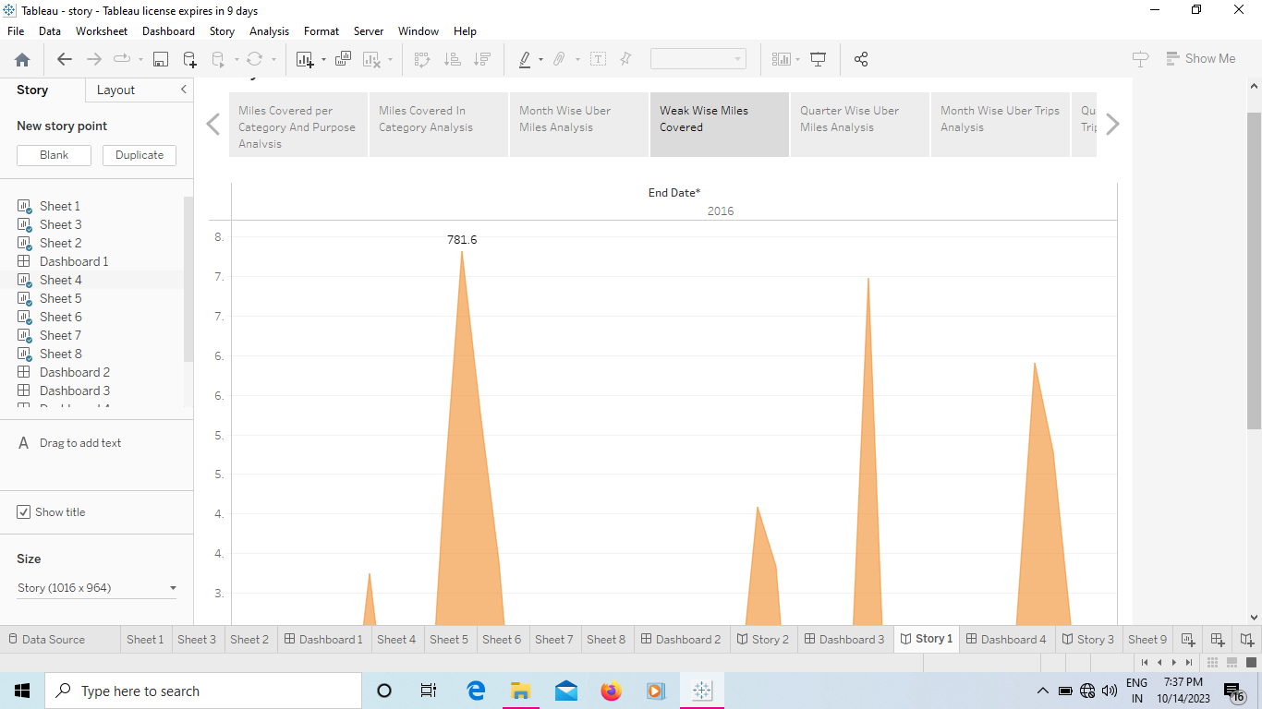

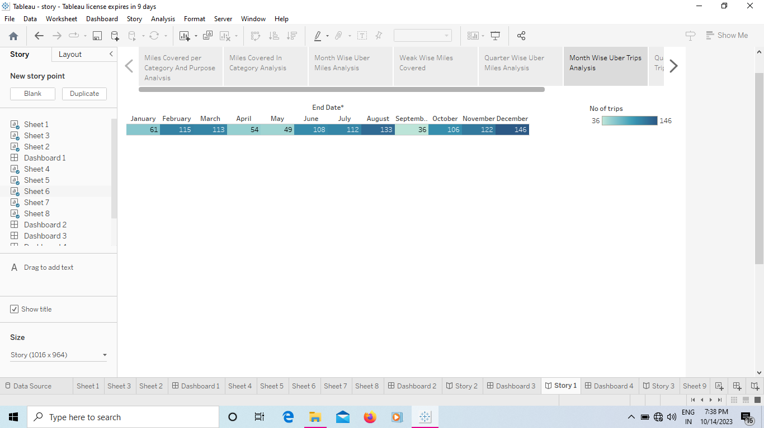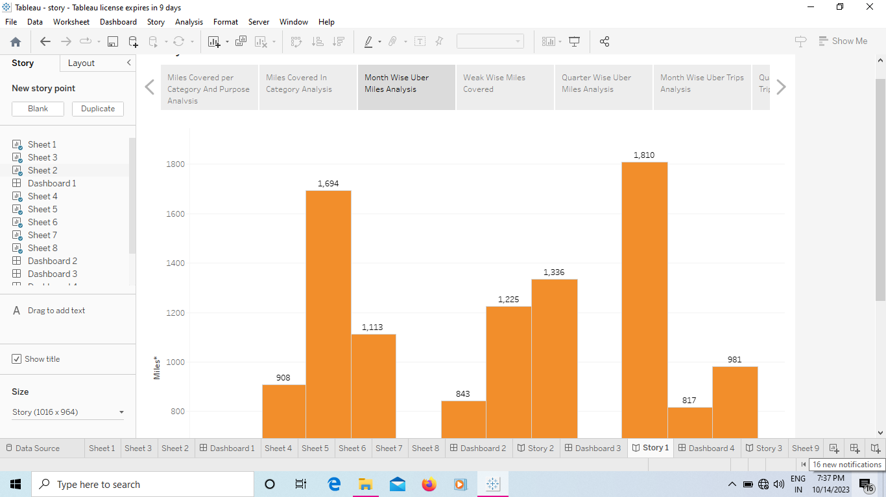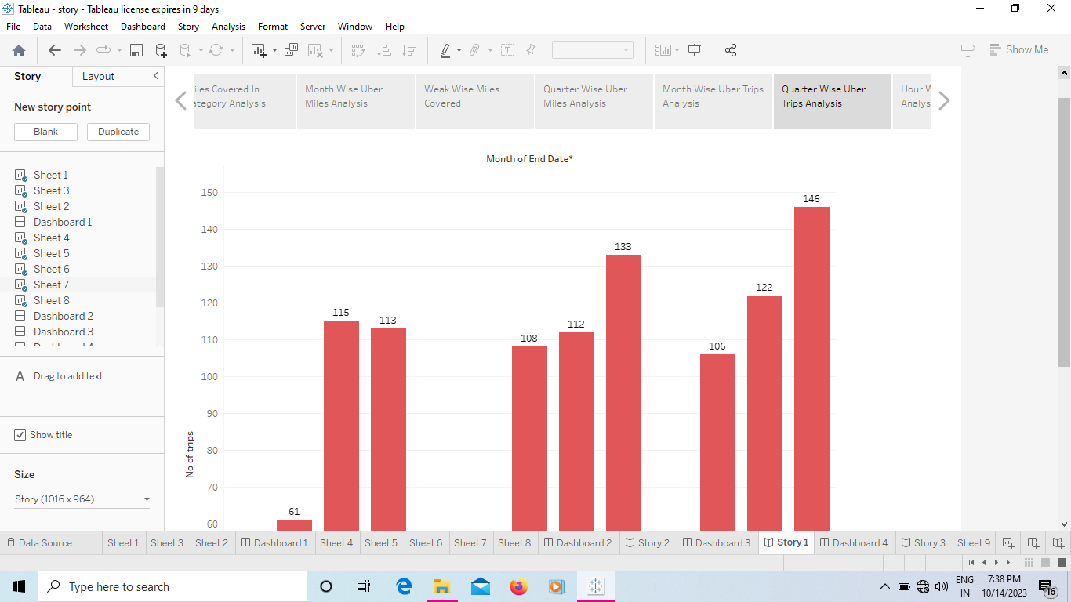

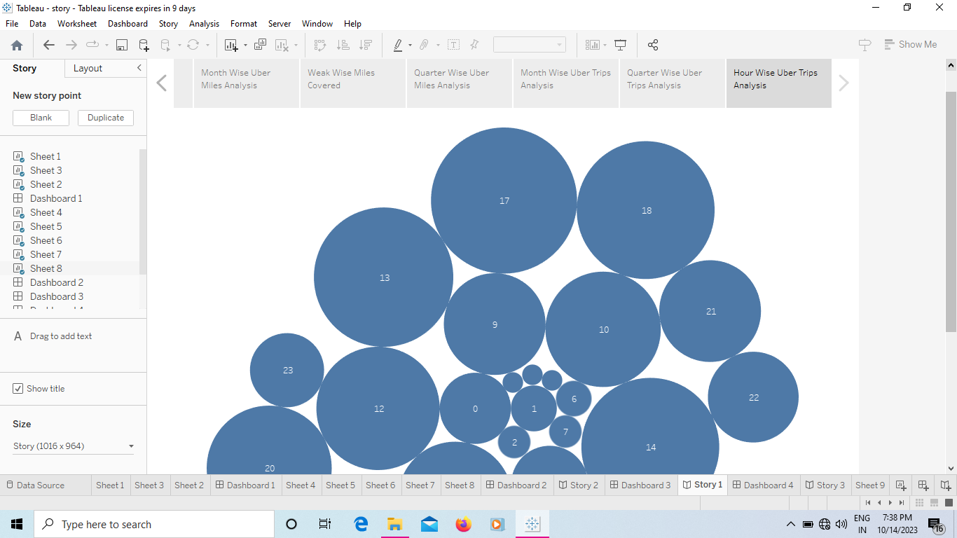

# 4. Advantages & Disadvantages

Voyage Vista: Illuminating Insights from Uber Expenditionary Analysis offers significant advantages in terms of education and strategic insights, it also presents challenges related to data accuracy, privacy, and keeping up with industry changes. Careful planning and consideration of these factors are crucial for the project’s success.

Disadvantages of this project are depending on the project’s approach, it could be seen as either promoting or critiquing uber, potentially leading to controversy or criticism.

# 5. Applications

The project’s applications are diverse and can benefit a wide range of stakeholders, from students and business to policymakers and researches, by providing a comprehensive view of uber’s journey and its impact on various aspects of society and the economy.

# 6. Conclusion

“Voyage Vista” has sought to illuminate the multifaceted aspects of uber’s journey and in doing so it encourages a deeper understanding of the ever-changing digital landscape and the transformative impact of technology on our world. It serves as a reminder that the journey itself, filled with challenges and successes, is a testament to the resilence and innovation that define the 21st century business landscape.

# 7. Future Scope

The future scope of this project is multifaceted, offering opportunities for ongoing research, education, industry analysis, and policy advocacy, as it continues to illuminate the dynamic landscape of the digital economy and its impact on society.